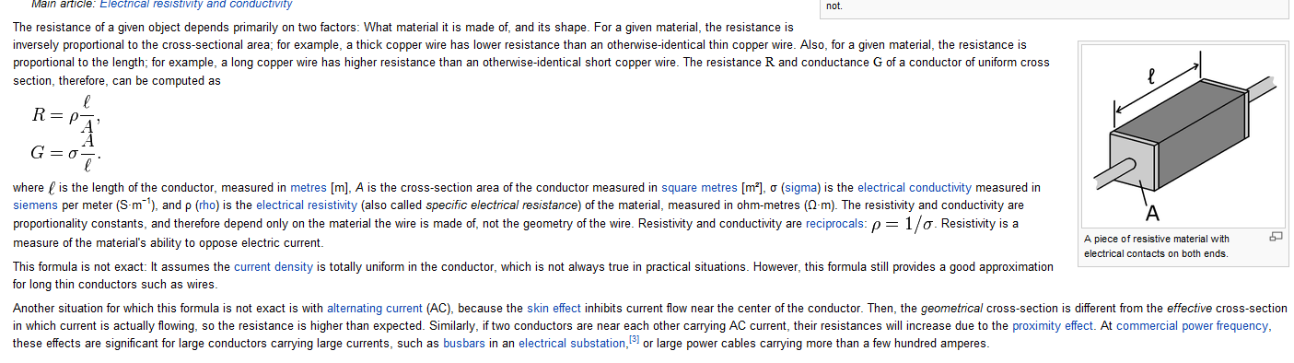

* resistance of a unit cube of the material measured between the opposite faces of the cube

| **Material** | [**Resistivity Coefficient**](http://www.engineeringtoolbox.com/resistivity-conductivity-d_418.html#Resistivity) **2) - *ρ -* *(ohm m)*** | [**Temperature Coefficient**](http://www.engineeringtoolbox.com/resistivity-conductivity-d_418.html#Temperature%20Coefficient) **2) *(per degree C, 1/oC)*** | [**Conductivity**](http://www.engineeringtoolbox.com/resistivity-conductivity-d_418.html#Conductivity) **- *σ -* *(1 /Ωm)*** |
| --- | --- | --- | --- |
| Aluminum | 2.65 x 10-8 | 3.8 x 10-3 | 3.77 x 107 |
| Animal fat |  |  | 14 x 10-2 |
| Animal muscle |  |  | 0.35 |
| Antimony | 41.8 x 10-8 |  |  |
| Barium (0oC) | 30.2 x 10-8 |  |  |
| Beryllium | 4.0 x 10-8 |  |  |
| Bismuth | 115 x 10-8 |  |  |
| Brass - 58% Cu | 5.9 x 10-8 | 1.5 x 10-3 |  |
| Brass - 63% Cu | 7.1 x 10-8 | 1.5 x 10-3 |  |
| Cadmium | 7.4 x 10-8 |  |  |
| Caesium (0oC) | 18.8 x 10-8 |  |  |
| Calcium (0oC) | 3.11 x 10-8 |  |  |
| Carbon (graphite)1) | 3 - 60 x 10-5 | -4.8 x 10-4 |  |
| Cast iron | 100 x 10-8 |  |  |
| Cerium (0oC) | 73 x 10-8 |  |  |
| Chromel (alloy of chromium and aluminum) |  | 0.58 x 10-3 |  |
| Chromium | 13 x 10-8 |  |  |
| Cobalt | 9 x 10-8 |  |  |
| Constantan | 49 x 10-8 | 3 x 10-5 | 0.20 x 107 |
| Copper | 1.724 x 10-8 | 4.29 x 10-3 | 5.95 x 107 |
| Dysprosium (0oC) | 89 x 10-8 |  |  |

Note! - the resistivity depends strongly on the temperature of the material. The table above is based on 20oC reference.

The electrical resistance of a wire is greater for a longer wire and less for a wire of larger cross sectional area. The resistance depend on the material of which it is made and can be expressed as:

*R = ρ L / A         (1)*

*where*

*R = resistance (ohm, Ω)*

*ρ = resistivity coefficient (ohm m, Ω m)*

*L = length of wire (m)*

*A = cross sectional area of wire (m2)*

The factor in the resistance which takes into account the nature of the material is the resistivity. Since it is temperature dependent, it can be used to calculate the resistance of a wire of given geometry at different temperatures.

The inverse of resistivity is called conductivity and can be expressed as:

*σ = 1 / ρ         (2)*

*where*

*σ = conductivity (1 / Ω m)*

**Example - Resistance in an Aluminum Cable**

Resistance of an aluminum cable with length *10 m* and cross sectional area of *3 mm2* can be calculated as

*R = (2.65 10-8 Ω m) (10 m) / ((3 mm2) (10-6 m2/mm2))*

*= 0.09 Ω*

**Resistance**

The electrical resistance of a circuit component or device is defined as the ratio of the voltage applied to the electric current which flows through it:

*R = V / I         (3)*

*where*

*R = resistance (ohm)*

*V = voltage (V)*

*I = current (A)*

**Ohm's Law**

If the resistance is constant over a considerable range of voltage, then Ohm's law,

*I = V / R         (4)*

can be used to predict the behavior of the material.

**Temperature Coefficient of Resistance**

The electrical resistance increases with temperature. An intuitive approach to temperature dependence leads one to expect a fractional change in resistance which is proportional to the temperature change:

*dR / Rs = α dT         (5)*

*where*

*dR = change in resistance (ohm)*

*Rs = standard resistance according reference tables (ohm)*

*α = temperature coefficient of resistance*

*dT = change in temperature (K)*

(5) can be modified to:

*dR = α dT Rs   (5b)*

**Example - Resistance of a Carbon resistor when changing Temperature**

A carbon resistor with resistance 1 kΩ is heated 100 oC. With a temperature coefficient *-4.8 x 10-4 (1/oC)* the resistance change can be calculated as

*dR = (-4.8 x 10-4 1/oC) (100 oC) (1 kΩ)*

*= - 0.048 (kΩ)*

The resulting resistance for the resistor

*R = (1 kΩ) - (0.048 kΩ)*

*= 0.952 (kΩ)*

*= 952 (Ω)*

